Huxian Peasant Painters

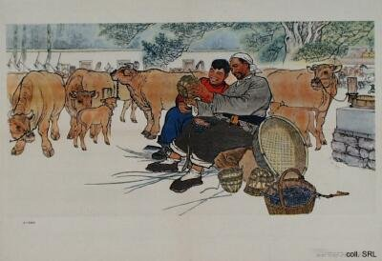
In the second half of the Cultural Revolution (early 1970s), the works of amateur artists among workers and peasants were given nation-wide attention and support. These amateurs were promoted as representatives of the innate creative genius of the masses, as living proof that everyone could and should practice art. As such, they became eminently emulatable models. The most well-known were the workers from Shanghai, Yangquan and Lüda, who mounted a successful exhibition in Peking in 1974; and the peasant painters from Huxian, Shaanxi Province. The latter even became internationally acclaimed for their naive, colorful style in painting when they were given the opportunity to exhibit their work in Paris in 1975.
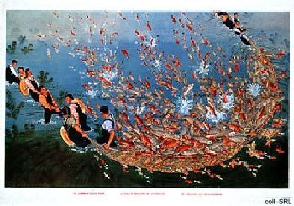 | 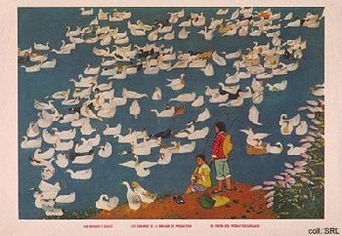
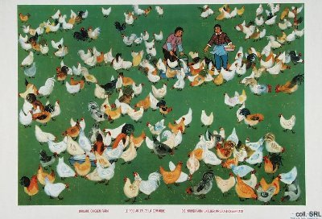
Although touted as amateurs, it was later admitted that the peasant painters had received extensive professional help and assistance in "the composition of their pictures, as well as with the conception, presentation and skillful rendering" in their work. The advice and assistance was often provided by precisely those professional artists who were no longer allowed to work themselves. The professional influences are particularly evident when one compares 'Huxian art' created during the Cultural Revolution with the examples of their work from the late 1950s and early 1960s. The flat, single-dimensional figures of the early paintings were replaced with more three-dimensional figures, and the later works testify to a greater use of perspective.
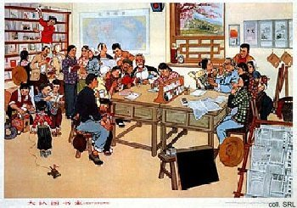 | 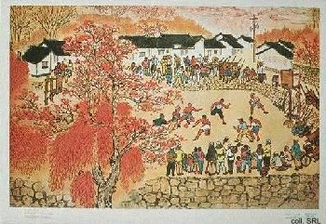

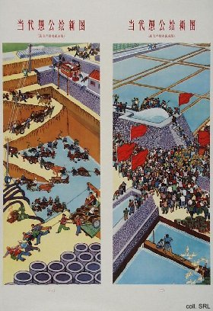 | 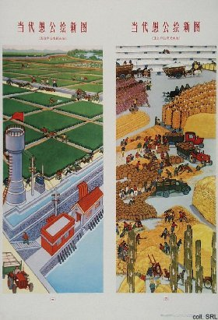
The Huxian painters excelled in the portrayal of local and national heroes and deep-space landscapes for propaganda purposes; and a strong geometric organisation and repeated patterns, for decorative purposes. Their highly political paintings provided idyllic slices of the good life in the rural areas, and were peopled with happy and enthusiastic peasants engaged in agriculture, political meetings and study sessions.
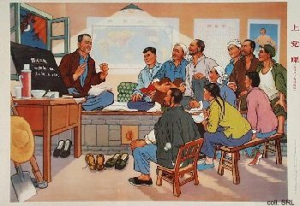 | 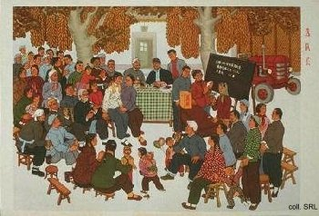
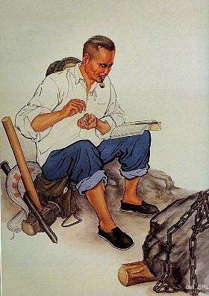
Various books and journals that supplied information on how to represent human beings, agricultural machinery, and others, were published in the early 1970s. Without doubt, these publications functioned as sources of inspiration for the amateur artists. They contained concise close-ups of workers, peasants and soldiers, young or old, male or female, at work or engaged in some other meaningful activity, sometimes from posters that had already been published, and were intended to provide good examples of how to represent human beings in art. In all probability, these source-books were responsible for the stereotyped and standardised quality of the propaganda posters published in this period.
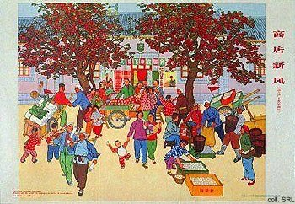 | 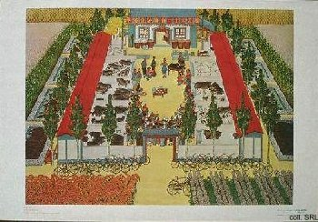

Sources:
Jutta Bewig, Bauernmalerei aus Huxian [Peasant Paintings from Huxian] (Frankfurt/M: Gesellschaft für Deutsch-Chinesische Freundschaft 1979)
Fine Arts Collection Section of the Cultural Group Under the State Council of the People's Republic of China (eds.), Peasant Paintings from Huhsien County (Peking: People's Fine Arts Publishing House 1976)
Stewart E. Fraser, (ed.), 100 Great Chinese Posters: Recent Examples of "the People's Art" from the People's Republic of China (New York N.Y.: Images Graphiques, Inc. 1977)
Maria Galikowski,, Arts and Politics in China, 1949-1984 (Hong Kong: The Chinese University Press 1998)
Guowuyuan wenhuazu meishu zuopin zhengji xiaozu (eds.), Shanghai, Yangquan, Lüda gongrenhua zhanlan zuopin xuanji [Selection of Works from the Exhibition of Workers' Art from Shanghai, Yangquan and Lüda] (Beijing: Renmin meishu chubanshe 1975)

