Exhibitions

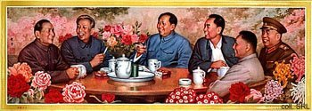
Materials from the Stefan R. Landsberger collection have been displayed on a number of occassions, starting in Hamburg in 1995. Another exhibition in which I participated was "The Chairman Smiles", organized by the International Institute of Social History (Amsterdam) in September 1996 and still running on the Internet. Here, not only posters from China were exhibited, but also from the former Soviet Union and Cuba.
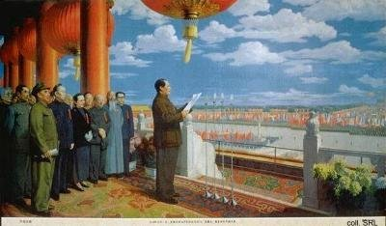
The "Paint it Red" exhibition, which took place in 1998, presented rare materials from the 1950s and the Cultural Revolution, prints from the 1970s and 1980s (the modernization era), as well as posters from the 1990s. The posters selected for this exhibition from the collections of the IISH and Stefan R. Landsberger can still be viewed on the Internet in the expanded Chinese section of "The Chairman Smiles".
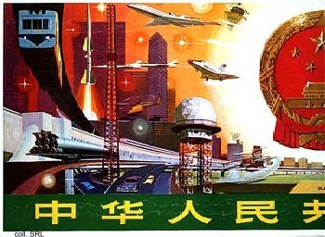 | 